27.Design TM using simulator to accept the input string wcw

]

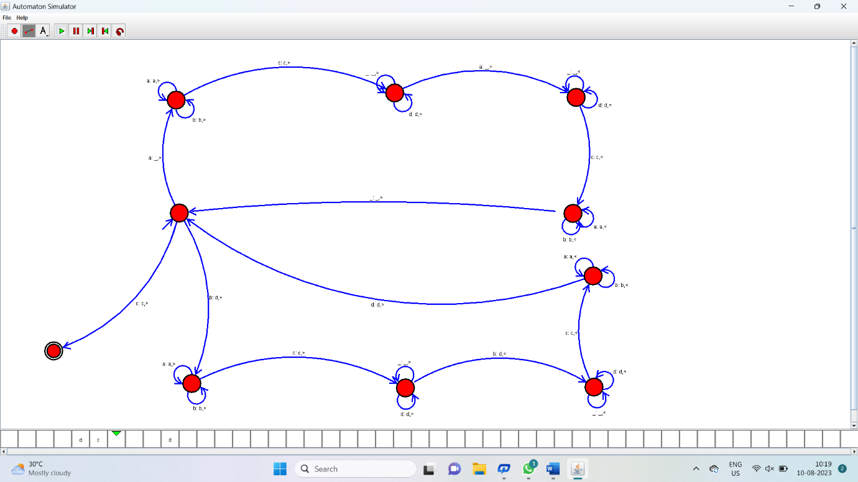

Result:

Hence it has accepted the input string wcw by using Turing machine simulator